# **KAMPUSKAGO**

# Url: <https://kampuskago.ng/>

**PROJECT REPORT**

**ON**

**DEVELOPING WEBSITE OPTIMIZATION PLAN**

# **Rotimi Ishola**

**PART 1: DETAIL CLIENT REPORT**

**Value for Priority**

|  |  |  |
| --- | --- | --- |
| **Low Priority** | **Medium Priority** | **High Priority** |
| Duplicate Title Tags | VSO | Optimized Title Tags |
| Duplicate Meta Description | Uncached JS and CSS files | 4xx error |
| Alt Attribute | Href and Language attributes | Duplicate Content Pages |
| Uncompressed Pages | Meta Descriptions | Uncompressing JS and CSS files |
| Low word count | Low text HTML ratio | Unminified JS and CSS files |
| Short title tags | Links and Crawlability | H1 Heading |
| No Doctype | Missing Canonical Tag | Indexability |
|  |  | Robots.txt |

**Project Overview**

This is a project report entitled “DEVELOPING WEBSITE OPTIMIZATION PLAN”, submitted by Rotimi Ishola. This project is a strategic technique to take a website int o top search result of a search engine. The goal is to increase the organic traffic through proper SEO keywords search for user friendly and audience engagement of the website, easy crawlability, optimized content, and profitability of organizational goals.

**Overview of the Buyer**

SEO allows you to focus your effort on the exact people you want to visit your website. 72% of businesses says SEO gives them the most bang for their buck compare to newspaper or television ads. Ideal visitors are more likely to become customers or subscribers if your website is well-designed, has right keywords, clear contact information, and polite customers service ready to answer any inquiries.

**Overview of the Organic Competitors**

After the research of the competitive analysis, I realize that the content used is in categories and a lot of social sharing through more on Google plus which translate into different links, for example, on social sharing used by one of the competitors, manybooks.net, the exact page of the link generates highest number of links, especially on social sharing Google plus, which eventually translate into many links. The vertical axis indicates type of social sharing used by the competitors and the horizontal axis indicates social shares and links amount. Also, the content that resonate with the customers is mostly pinnable images which should be placed on the exact page of the domain in order to generate links and site should incorporate more content on Google plus to get more engagements with the audience and eventually generate links. There should be articles and blogs on different pages of the site and should be link together for purpose of effective search and link sharing that can lead to high ranking on Google search. To crown it all, looking at the metrics, the top competitor is likely to generate more links on the root domain due to blogs and engagements from other sites and engagements from the customers.

**Technical Review**

There is no Robot.txt file on the website

**Recommendations for Robot.txt file:**

* To control Search Robot.
* Robot.txt file defines which areas of website crawlers are allowed to search.
* The web page will not be rank when Robot.txt file is disallowed.
* Before file is save to the root directory of the site, it is important to check the syntax because, any minor error can lead search bots disregarding the disallow rules and crawling website that should not index.

**Pages that Robot.txt do not crawl:**

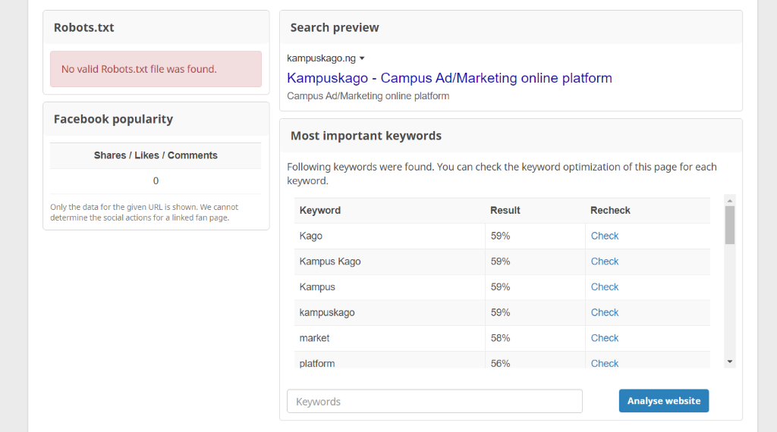

**Reasons:**

* [**https://kampuskago.ng/Market**](https://kampuskago.ng/Market)**:** Image SEO is not found in any alt attribute of an image, not found in any image URL, not used within the headings, and missing in the H1 heading. Because HTML content is not well optimized.
* [**https://kampuskago.ng/Contact**](https://kampuskago.ng/Contact) **Us:** Missing Title tag and Meta Description is not within the first 120 characters because of fault in Meta attribute.
* [**https://kampuskago.ng/Online**](https://kampuskago.ng/Online) **Platform:** At the end within the title: **platform** (important keywords should be at the beginning. In Image SEO, not found in any alt attribute of an image: **Online, Platform,** not found in any image URL: **Online, Platform,** not found in an image title: **Online, Platform,** not in the page's text content: **online,** because of HTML is not Optimized.

The Existing Robot.txt file:

* **Domain**: Occurs in the domain: **Kampus, Kago.**
* **Stops Words:** None of the keywords is a known stop word.

Because the domain is containing the main keyword and relevant for SEO and online marketing.

There are 101 errors after site audit.

Click or copy the link to see the Error research work**:**

<https://1drv.ms/x/s!AtI6wJbrV6AjhBspcK4yJ1YsaTCd?e=lX3a1S>

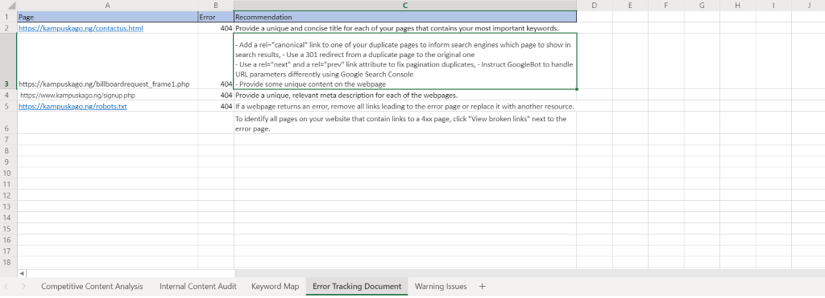

Click or copy the link to see the Improper redirect research work**:**

<https://1drv.ms/x/s!AtI6wJbrV6AjhB0BuYXUx_hQeMOJ?e=DMbRWZ>

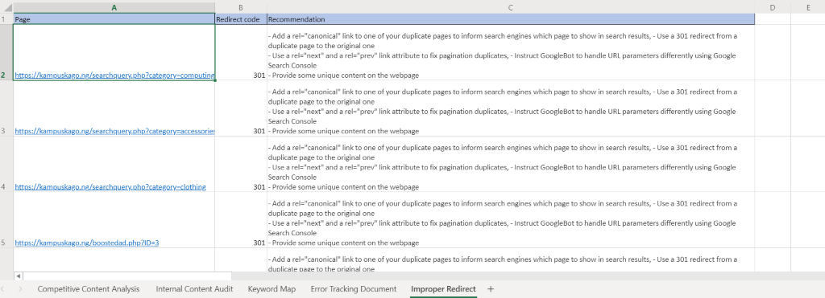

**Content Recommendation**

Click or copy the link to see the Content Recommendation research work**:**

[**https://1drv.ms/x/s!AtI6wJbrV6AjhCFggPMDVI4IPBFL?e=roUyUT**](https://1drv.ms/x/s!AtI6wJbrV6AjhCFggPMDVI4IPBFL?e=roUyUT)

**Analysis of Content**

41 pages have duplicate content issues. A webpage is considered duplicates if their content is 85% identical and having duplicate content will significantly affect the SEO performance. Search engines may consider duplicate pages as an attempt to manipulate search engine rankings and, as a result, your website may be downgraded or even banned from search results.

**Content Recommendations:**

* Focus on getting links from Google plus.
* Optimize Title tags between 10 –60 characters.
* Create a section of content on blog.
* Create a content section on eBooks categories.
* Use more text and images to generate page authority.
* Use video to capture more of domain authority.
* Incorporation of right keywords for SEO optimization.
* Provision of a concise and relevant H1 heading for each page of the site.
* Use of Social media to generate links.

Content length need to be adjusted for the appropriate one needed for SEO ranking.

Does the content sufficiently use keywords? No

Does the content link to other pages of the site where appropriate? For some content, Yes, too many duplicate contents.

Does the content include additional resources such as images, videos, etc.? Less images, but there is a need for videos to gain domain authority.

Does the content include a call to action? No

Does the content sufficiently address a buyer's question or concern that would have brought them to this page? No

**Recommended Pages**

Click or copy the link to see the Content Recommendation research work**:**

**https://1drv.ms/x/s!AtI6wJbrV6AjhCFggPMDVI4IPBFL?e=mR4tgl**

**Success Metric**

* **5 Metrics to monitor:**

1. Title tags
2. Keywords: Textbook in campus, online books, etc
3. Duplicate Titles
4. H1 heading
5. Content

* **Main keywords are**: Textbook in campus, online books, desktop computer, Free ebook download, traditional African Cloth.

The Client need to be aware of improvement to keywords, because keywords are prone to changes through algorithm updates and trending topics.

* **To Increase Traffic,** the analytics metrics that should be tracked**:**

1. Comparing where the site is currently ranking with where the ranking stands after improvement.
2. Checking 12 months metric

* **User Engagement,** the following metrics should be tracked**:**

1. Engagement metric.
2. Organic landing pages: based on organic traffic, revealing how pages are indexed and rank.
3. Conversion metric.

**PART 2: VIDEO PRESENTATION**

**The 2 Areas that the Website can Improve:**

* Cutting down overused keywords.
* Adding more text to homage and other pages.

**The presentation Video is added here:**

**https://vimeo.com/user56651418/review/474203385/ab066a1dd4**